
Koneru Lakshmaiah Education Foundation
(Deemed to be University estd. u/s. 3 of the UGC Act, 1956)
Off-Campus: Bachupally-Gandimaisamma Road, Bowrampet, Hyderabad, Telangana - 500 043. Phone No: 7815926816, www.klh.edu.in

STUDENT CASE STUDY EXECUTION REPORT
Department | FED
Subject | DSA-2
Academic Year | 1-111 Semester | 2025-26
Faculty Name | Mohd. Razia Alangir Banu
Student Name | P. Yaswanth Surya
Roll Number | 2520030581
Branch | CSE
Course Outcome | CO 4
Case Study Topic: Ambulance Routing System using Shortest Path Algorithm
Work Done Summary:
In this case study, we implemented the Shortest Path Algorithm (Dijkstra's Algorithm) to optimize ambulance routing in a hospital network. The system calculates the shortest route between hospitals and patient locations, minimizing travel time during emergencies. Road networks are represented as weighted graphs where intersections are vertices and road distances are edge weights.

Implementation Details:

• Represented the road network as a weighted graph.
• Stored hospitals, patient locations, and road distances.
• Implemented Dijkstra’s Algorithm to find the shortest path.
• Used a priority queue to improve efficiency.
• Calculated the minimum travel distance from the hospital to the patient.
• Displayed the optimal route and total distance.
• Compared different route options and selected the shortest one.

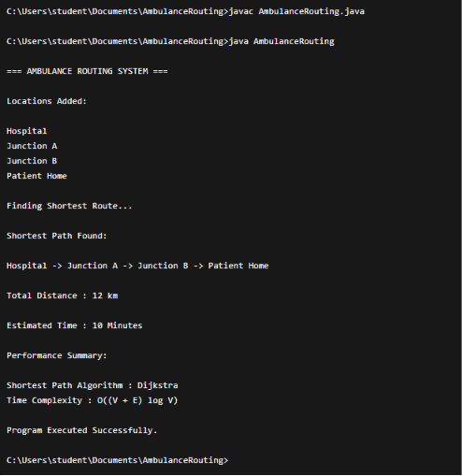

Result: Screenshots / Output
The AVL Tree maintained balanced indexing and improved retrieval efficiency.
Sample Output:
- Content ID: 101 → Avengers Endgame
- Content ID: 205 → Stranger Things
- Content ID: 312 → Money Heist
- Search Result: Content Found
- AVL Rotation Applied Successfully

Time Complexity:
- Graph Representation: O(V + E)
- Dijkstra's Algorithm: O((V + E) log V)
- Shortest Path Retrieval: O(V)
- Priority Queue Operations: O(log V)
Where:
- V = Number of Locations (Vertices)
- E = Number of Roads (Edges)

Conclusion:
The Shortest Path Algorithm successfully identified the optimal route for ambulances in emergency situations. By minimizing travel distance and response time, the system improves patient care and emergency service efficiency. Dijkstra’s Algorithm proved effective for real-time route planning in hospital transportation networks.
.

GitHub Link: https://github.com/yaswanthsurya-99/DSA-2
Student Signature Faculty Signature

